**Development Journal**

Step 1: Player Movement

Created canvas

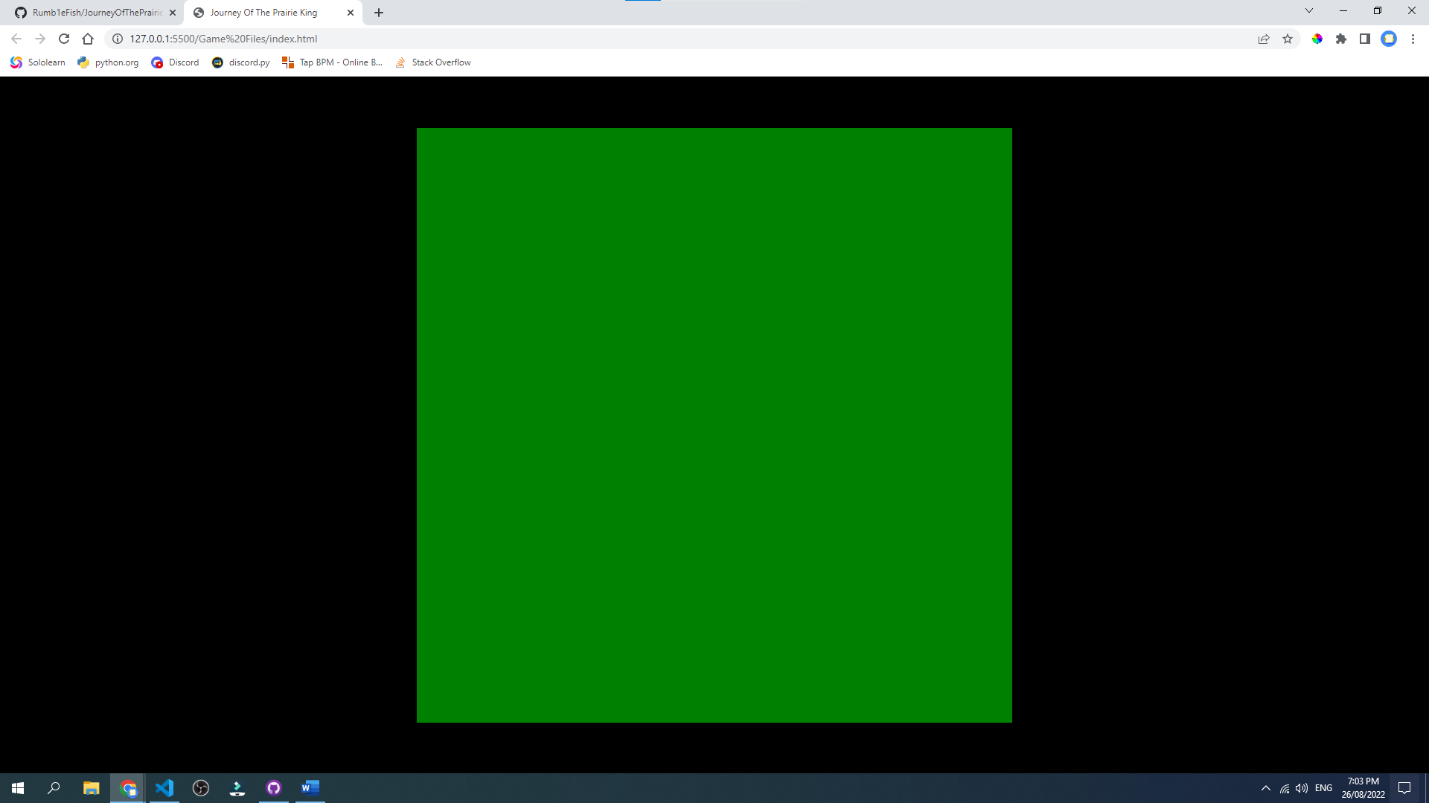

Created movement, not yet able to detect canvas boundaries. Player image is stretched on the y axis for some reason. Looked for help to fix this on Stack Overflow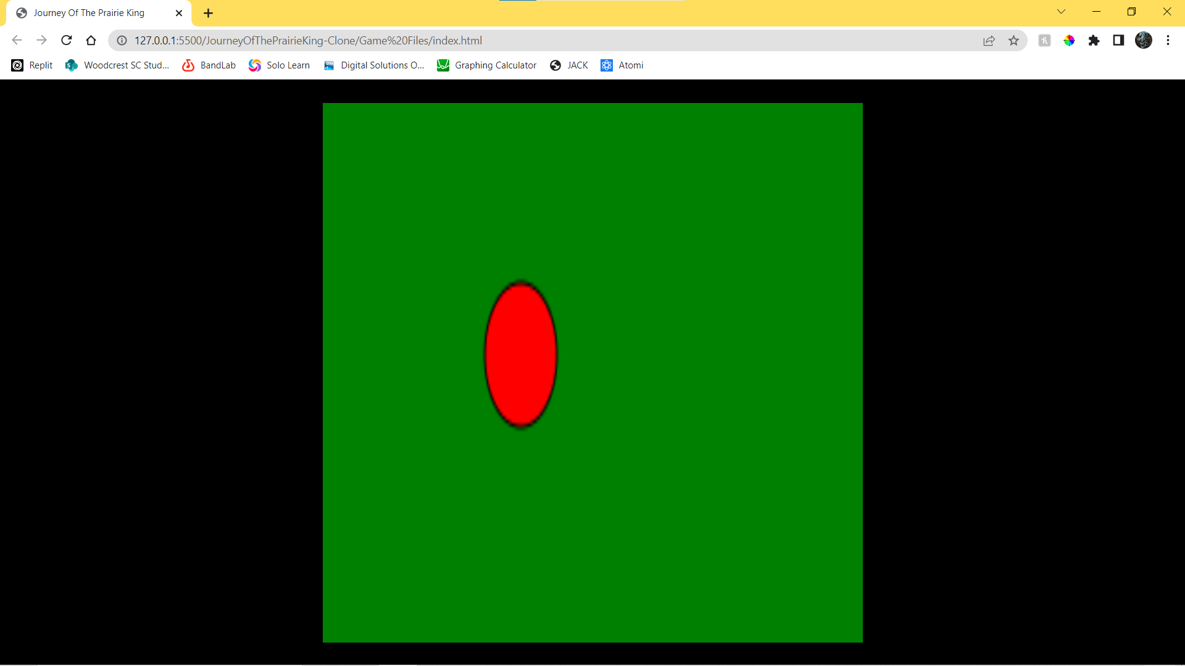

Created collision detection for border of canvas.

